REDLINE
Medical Supplies & Equipment Trading
ريد لاين للتجارة في المستلزمات والمعدات الطبية

Technical Proposal (TPD)
العرض الفني
Technical scope, architecture, migration, security, testing and handover

Project | Odoo ERP Implementation - Graduation Project (simulation)
Document code | RL-TPD-001
Version | 1.0 (final)
Preparation date | 25 October 2026
Business reporting period | 1 May 2026 – 30 September 2026
Target platform | Odoo 19.0 (Enterprise edition assumed)
Prepared by | Mohamed Mahmoud Abdel Bary, Mohamed Essam El-Din Youssef, Ahmed Mahmoud Mohamed, Fathy Adel Fathy, Omnia Haitham
Currency | EGP - Egyptian Pound
Disclaimer: all companies, partners, bank details and transactions in this project are fictional or illustrative simulation data. Nothing in this document claims that the configuration has been installed, imported or tested on a live Odoo server.

Contents
1 | Technical scope
2 | Selected modules and dependencies
3 | System architecture
4 | Functional versus technical requirements
5 | Data migration methodology
6 | Custom modules and integrations (proposed)
7 | Data models and import dependencies
8 | Integration considerations
9 | Security and access control
10 | Testing and deployment strategy
11 | Risks and mitigations
12 | Deliverables and exclusions
13 | Maintenance and handover
Section numbers are used for cross-references throughout the document set (e.g. 'SSD 4.2' = Solution Design Document, section 4.2).

1. Technical scope
The technical scope covers configuring Odoo 19.0 (Enterprise edition assumed) for a single legal company with three branches and four warehouses; loading master data and opening balances; configuring tracking (lots, serials, expiry), valuation and accounting; defining security; preparing testing and deployment. Items that need custom code or Enterprise-only apps are described as proposed work; none has been built, installed or tested.
Assumption. Version note: 'Odoo 20' could not be verified as an available release; this proposal is written for Odoo 19.0. If another version is chosen, technical names and menu paths must be re-verified.

2. Selected modules and dependencies
Module | Depends on | Why selected | Class
Contacts | base | Partners with terms and credit | Standard
Sales | Contacts, Product, Account | Quotation to invoice | Standard
CRM | Contacts, Sales | Leads, pipeline, sales teams, forecast | Standard (config)
Purchase | Contacts, Product, Account | RFQ to bill | Standard
Inventory | Product, Account (stock_account) | Lots/serials/expiry/valuation | Standard
Product Expiry | Inventory | Expiration dates, FEFO | Standard (config)
Accounting | Contacts, Product | Ledgers, taxes, reporting | Standard / Enterprise
Quality | Inventory | Receipt inspection | Enterprise
Barcode | Inventory | Scanning | Optional
Studio | Web | Custom fields/approvals | Optional
Custom module redline_extras | Sales, Stock, Account | Credit block, warranty, branch rules | Proposed

3. System architecture
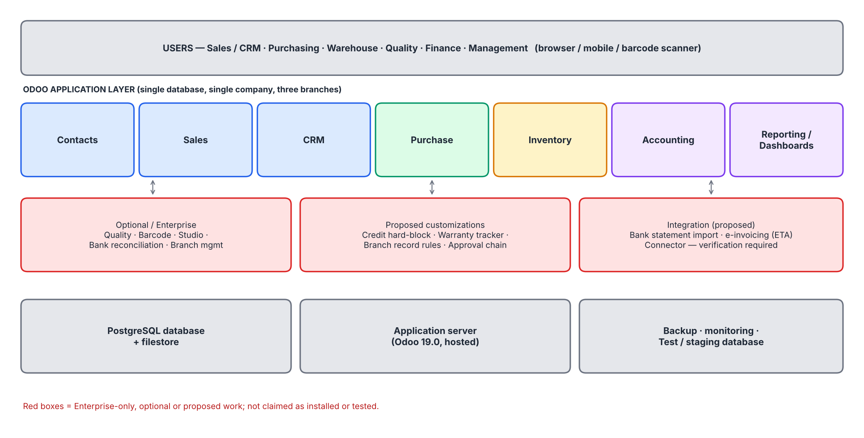
Figure 1 - Logical architecture (red = Enterprise/optional/proposed)
Component | Proposal
Application | Odoo 19.0 (Enterprise); Odoo Online / Odoo.sh / on-premise to be decided
Database | PostgreSQL, daily backups; production and staging databases
Environments | Staging (UAT and migration rehearsal) and Production
Monitoring | Provider monitoring; log review; disk and backup alerts
Network | HTTPS only; restricted admin access; MFA for administrators

4. Functional versus technical requirements
Module | Requirements | Standard / config | Enterprise / optional | Customization (proposed) | Manual
Contacts | 4 | 3 | 0 | 1 | 0
Sales | 9 | 7 | 0 | 2 | 0
CRM | 8 | 7 | 0 | 1 | 0
Purchase | 7 | 7 | 0 | 0 | 0
Inventory | 17 | 15 | 2 | 0 | 0
Accounting | 12 | 10 | 1 | 0 | 1
Reporting | 4 | 3 | 1 | 0 | 0
Security | 5 | 2 | 0 | 2 | 1
Non-functional | 4 | 2 | 0 | 0 | 2
Migration | 5 | 4 | 0 | 1 | 0

Technical requirements derived from functional ones: (1) enable lots/serials/expiry and FEFO; (2) automated valuation with the account mapping in Organization_and_Accounting_Charts.xlsx; (3) Arabic/RTL report templates; (4) analytic plan 'Branch'; (5) approval rules; (6) record rules per branch/warehouse; (7) import templates; (8) backup/restore.

5. Data migration methodology
- Analyse: inventory legacy files (customers, vendors, products, stock cards, open invoices). Map: legacy fields -> Odoo fields (see CSV headers).
- Cleanse: remove duplicates, standardise names (Arabic/English), validate tax IDs and terms.
- Load (staging): dependency order - accounts, journals, warehouses/locations, categories, partners, products, lots/serials, opening stock, reordering rules.
- Validate: counts, mandatory fields, duplicates, foreign keys, quantity per lot/serial, value per account.
- Reconcile: opening value EGP 24,170,200.00; receivable/payable control accounts; trial balance.
- Rehearse on staging twice; cut-over during a low-activity weekend (Friday/Saturday); keep the legacy system read-only for 30 days.
Check | Method | Expected (simulation)
Products imported | Count vs CSV | 24
Partners imported | Count vs CSV | 13 customers, 6 vendors
Accounts imported | Count vs CSV; unique codes | 101
Serial uniqueness | Distinct serials = rows | 186
Opening stock value | Valuation report vs opening journal | EGP 24,170,200.00
Trial balance | Debits = credits | Balanced

6. Custom modules and integrations (proposed)
Not implemented. The items below are PROPOSED work. They are not built, installed or tested. Estimates are in the Financial Proposal as optional customization.

ID | Item | Description | Requirement | Approach | Effort (days, indicative)
C-01 | Credit hard block | Block confirmation when credit limit is exceeded unless Finance approves | CON-004 | Override of sale order confirmation; approval group | 4
C-02 | Warranty tracker | Warranty end date per serial; report and expiry reminders | SAL-007 | Custom fields on stock.lot + report | 5
C-03 | Branch record rules | Visibility by branch and warehouse | SEC-002 | Security groups + record rules | 5
C-04 | Approval chain | Quotation > EGP 500k; segregation of duties | SAL-002, SEC-004 | Studio approvals or custom module | 6
C-05 | History loader | Script to load five-month history as posted documents | MIG-005 | Python import script on staging | 6
C-06 | Arabic report templates | RTL invoice, delivery slip, statement | NFR-001 | QWeb template tuning | 5
C-07 | CRM tender tracking | Tender reference, deadline and bid bond fields on opportunities | CRM-008 | Custom fields on crm.lead + filters | 3

7. Data models and import dependencies
Odoo model | Key fields (simulation) | Depends on | File
res.company | name, street, currency, email | - | 01
account.account / account.group | code, name, account_type, reconcile | company | 08
account.journal | code, type, default account | accounts | 09
stock.warehouse / stock.location | code, name, usage | company | 02, 03
product.category | costing, valuation, account props | accounts | 04, 10
res.partner | ref, terms, credit limit, tax ID | company | 06, 07
product.template | default_code, tracking, expiry, prices, barcode | category, vendor | 05
stock.lot | name, product, expiration date | product | 11
stock.quant (inventory adjustment) | product, location, lot, qty | lot, location | 12
stock.warehouse.orderpoint | min, max, route, vendor | product, warehouse | 13

8. Integration considerations
Integration | Need | Option | Status
Banks (CIB, NBE) | Statement import, payment files | CSV/OFX import; bank connector if available | To verify
E-invoicing (Egyptian Tax Authority) | Possible legal requirement | Localization/connector or middleware | Out of scope; verify obligations
Barcode scanners | Warehouse scanning | Odoo Barcode app with Bluetooth/mobile scanners | Optional
Email | Send quotations, statements | Outgoing mail server (SMTP) | Standard
Existing spreadsheets | One-time migration | CSV import package | Prepared

9. Security and access control
- Role-based groups per BDC 6; least privilege; administrators separate from business users.
- MFA for administrators; password policy; session timeout; HTTPS.
- Record rules for branch/warehouse (proposed); segregation of duties (proposed).
- Audit: tracked fields, chatter, server logs; periodic access review.
- Data protection: encrypted backups; masked data on staging; no credentials in repositories or documents.

10. Testing and deployment strategy
Stage | Activities | Owner | Status
Unit/config tests | Module settings, account mapping, tracking flags | Ahmed Mahmoud Mohamed | Documented
Data tests | Import counts, reconciliations | Ahmed Mahmoud Mohamed | Simulated (workbook formulas)
UAT | 77 test cases mapped to 75 requirements | Fathy Adel Fathy | Simulated review; live pending
Training | Role-based sessions (BDC 10) | Fathy Adel Fathy | Planned
Deployment | Staging rehearsal -> production cut-over -> hypercare 2 weeks | Mohamed Mahmoud Abdel Bary | Planned

11. Risks and mitigations
Risk | Likelihood | Impact | Mitigation
Enterprise feature unavailable | Medium | Medium | Fallback manual checklist; evaluate cost/benefit
Custom code upgrade conflicts | Medium | Medium | Keep custom module small; test upgrades on staging
Import errors in lots/serials | Medium | High | Rehearse; automated validations
Tax configuration errors | Medium | High | Accountant sign-off
Performance with growth | Low | Medium | Indexing, hosting sizing, archiving
Low user adoption | Medium | High | Training, super-users, hypercare

12. Deliverables and exclusions
Included | Excluded
Configuration specification (BDC), SSD, GAWF, BRD, RTM, UATD | Live installation or hosting of Odoo
Entity data workbooks and CSV import package | Statutory tax filing, e-invoicing integration
Proposed customization specifications | Building the custom module (optional, FPD)
Training outline and user-guide outline | Payroll, manufacturing, e-commerce
Validation report | Real bank connections or credentials

13. Maintenance and handover
- Hypercare: two weeks after go-live with daily review; then monthly health checks.
- Handover pack: configuration specification, import package, UAT results, user guides, backup/restore runbook, open-issues list.
- Support model (proposed): super-users per department, IT administrator, vendor support contract (illustrative in FPD).
- Upgrades: staging first; regression using UATD; custom module re-tested.

